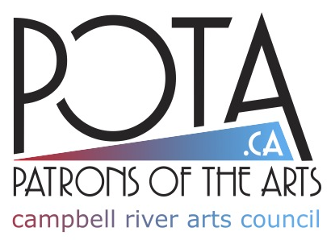
Patrons of the Arts
Supporting Visual and Performing Arts in Campbell River
FUNDING APPLICATION

ABOUT POTA
Patrons of the Arts began in 2019 as part of the Campbell River Arts Council. We support and celebrate our visual and performing artists. To this end, POTA raises funds and distributes them within the local arts community. Funds are raised through self-produced events, private donations, and membership. Artists and event producers are invited to apply for funding to assist with activities.
CRITERIA FOR SUPPORT
- POTA support is to benefit Campbell River and Vancouver Island north communities.
- The project or event reflects the artist’s creative process and cultivates an artist’s craft and vision.
- This can include, but is not limited to, funding an event, or assisting one or more artists involved with an activity.
- Examples of activities: Concerts, dance and theatre presentations, prizes for artistic competitions, guest artist fees for educational workshops, artist fees for art installations, opening receptions.
- Artists cover the purchase of materials and cost distributing of their art.
- Artists include, but are not limited to, painters, photographers, potters, carvers, sculptors, writers, musicians, dancers, actors, and other creators and performers.
- There are no application deadlines, however, POTA’s capacity to fund activities may vary throughout the year. We suggest applying at least six months prior to your event. POTA will acknowledge all applications received.
- Funds are provided upon approval from POTA.
- Maximum request amount is $1,000.
ACKNOWLEDGEMENT: POTA & CAMPBELL RIVER ARTS COUNCIL
  - To build awareness of POTA and the Campbell River Arts Council so that we may help more artists and demonstrate accountability to our funders, our support must be recognized in your activity’s promotional materials. This includes posters, programs, print/digital ads, social media posts, onsite signage.
  - POTA and CR Arts Council logos will be provided for these purposes.
DATE APPLICATION RECEIVED:
AMOUNT REQUESTED: AMOUNT GRANTED:
DATE REPORT RECEIVED:
ABOUT YOU
ORGANIZATION:
CONTACT PERSON:
PHONE: EMAIL
ADDRESS:
DESCRIBE THE PROJECT, ACTIVITY, OR EVENT

IF YOU HAVE AN EVENT
EVENT DATE: TICKET PRICE:
ESTIMATED ATTENDANCE: # OF VOLUNTEERS:
FUNDING REQUEST
AMOUNT:
PURPOSE (ARTIST FEE, PEOPLE’S CHOICE PRIZE, ETC):
DOES THIS COVER AN ARTIST’S FEE? IF SO, POTA WILL DIRECTLY PAY THE ARTIST.
ARTIST’S NAME:
ARTIST’S PHONE: EMAIL:

POST-EVENT APPRECIATION
POTA requires a short report with photos, summarizing your event’s highlights and attendance, within one month following your event. POTA is permitted to use this information to promote its programs and demonstrate accountability to funders.
DO YOU AGREE TO PROVIDE THIS INFORMATION? _______________
SUBMITTING THE APPLICATION
By submitting this application, the applicant hereby declares that:
- The applicant meets all of the criteria of fundamental eligibility for this program.
- To the best of your knowledge, the information provided is complete and true.
- This application has been approved by the board of directors of your society, if applicable. - The applicant is committed to providing safe and respectful working conditions and to
fostering a workplace free from discrimination, harassment and sexual misconduct.
Delivery options:
  - Email to info@pota.ca
  - Mail to POTA, c/o Campbell River Arts Council, 2131 South Island Hwy, Campbell River, BC V9W 1C2
  - Give to a POTA Board Director. A current list of members is at www.pota.ca.
DATE _______________________________________
APPLICANT’S SIGNATURE ____________________________________________
